SILVER
Assembly Manual

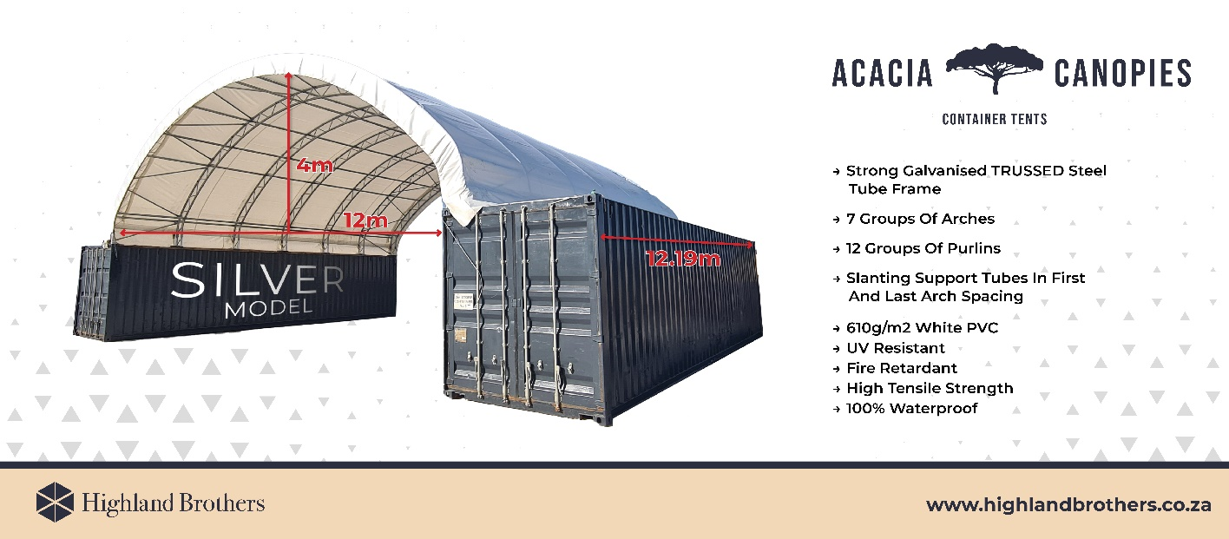
Congratulations on your purchase of our Acacia Canopy Silver model.. This unit is a combination of excellent manufacturing and design. It is comprised of a rigid frame and a durable cover. For easy assembly, we have marked all the parts with codes. With proper installation, use and maintenance, your unit will provide many years of good and suitable service.

READ ALL THE INSTRUCTIONS BEFORE ASSEMBLY！
- The proper erection and installation of this building requires a high level of care and safety. We recommend the safety regulations be complied with during the installation. It includes but is not limited to:
  - Safety hats, protective eyewear, protective clothing and protective gloves
  - Safety harnesses for all elevated workers
  - Proper ladder, cage, and safety operation
- Site selection: Choose a solid level location for your building. Do not install the building where the ground could not keep the building steady. Do not install the building where the ground could not bear the weight of the building. Do not install the building in soft grass ground or wetland.
- Be cautious with the surroundings. Keep work area clean. Do not set up it near snow drifts, in slippery places, or in wet location. The cover of the building will protect against normal falling leaves and light debris, however, large, fast or sharp falling items etc. may cause a puncture or tear in the cover material. So, keep the building away from such harmful things. Be careful with power and heat sources. Don’t keep heat sources, flammable and explosive hazardous goods near the tarpaulin. Don’t expose to open flame.
- Chose a windless day to install the canopy. It is very difficult to attach the cover in heavy wind. Do not install your building where there usually has strong wind. Please remove or roll up the tarpaulin of the building during strongly windy days.
- If the instructions in the manual are not followed, we are not responsible for any damage or accident.
Don’t make alteration of the frame.

Items Needed For Installation
      - Cherry Picker 2 T
      - Welder and Grinder
      - 19mm and 17mm Spanner and Socket Set
      - 2 x 6m Lengths of 20 x 20 square metal tubing
      - 6 m Length Flat Bar (40/50)
      - Duct Tape x 6 , and Silicon Spray

ASSEMBLY PROCEDURE
- Prepare location and place all unit boxes near sight. Perform an inventory check before beginning, to be certain all components are available for installation.
- Secure base plates flanges to base surface.
- Assemble all groups of arches.
- Begin frame assembly with front end arch, first interior arch, purlins, etc.
- Add to assemble other groups of arches.
- Install main cover over frame.
- Install end covers over end panels.
Read all the detailed instructions and notices in the following assembly instructions!

MAINTENANCE AND CARE
- If the cover was accidently damaged during the use, contact the local supplier for advise on the repairing method
- When attaching the cover, choose a windless day to replace the cover. Begin with making certain all the bolts of the frame and the tensioning equipment’s well fixed.
- To extend the life of the cover, put small duct tape or foam rubber (provide it by yourself) on the frame that comes to in contact with cover. The tape and foam rubber acts as a cushion to avoid rubbing damage to the cover over years.
- Periodically the building should be completely inspected and maintained internally and externally to make certain the canopy remains properly installed and secured. Including: check all bolts and hardware connectors to be certain they are in place and tightened, the base plates are still fixed firmly, check and adjust the ropes if in need, clean the cover with suitable washing. Allowing dirt and debris to sit on cover over an extended time will damage cover irreparably.

Thanks again for choosing this quality product. The following is the detailed assembly instructions for you starting the assembly.

Parts List
40'L Container Shelter
Part Code | Description | Quantity
1 | Center roof section | 7
2 | Mid roof tubing | 14
3 | Lower roof tubing | 14
4 | Shoulder tubing | 14
5 | Purlins | 72
6L | Base plate, left side | 7
6R | Base plate, right side | 7
7 | Bracing | 24
7A | Bracing at four corners | 4
8 | Brackets for bracing | 56
9 | Connection bolts for roof tubing | 224
10 | Connection bolts for purlin | 84
11 | Connection bolts for bracing | 56
13 | Tie down ratchet | 14
14 | Nylon strap for tie down ratchet | 14
15 | Lower tensioning tubing | 2sets
16 | Roof cover | 1set
17 | Lace rope for end of roof cover
18 | Plastic cap for tensioning tube | 4
20 | Choke Wire tensioning bracket | 4
21 | Steel wire tensioning (Choke Wire) | 2
22 | Turnbuckles and Clips | 4sets

FRAME ASSEMBLY
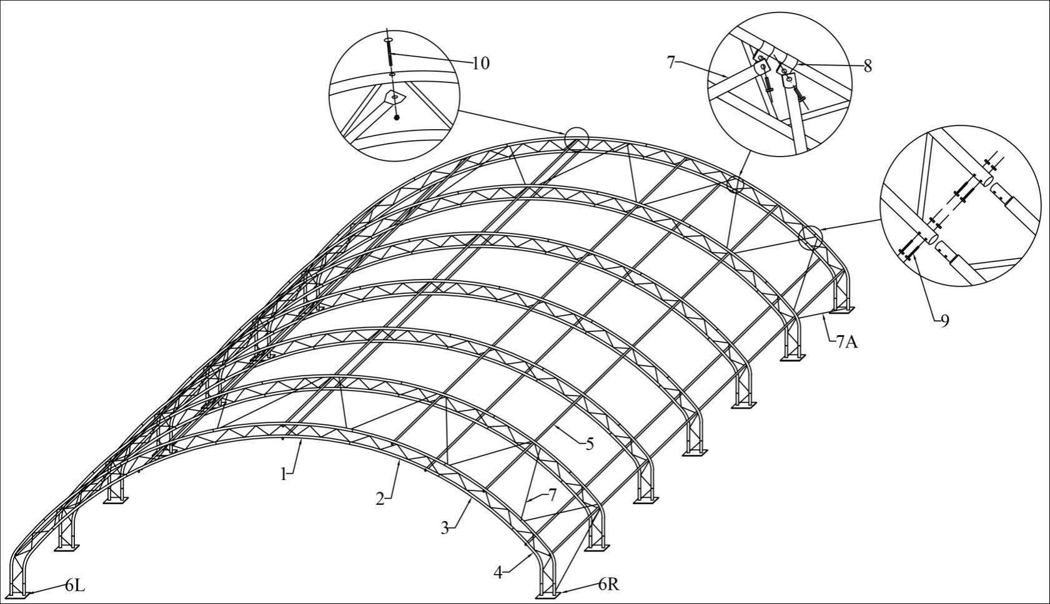

STEP 1 - CONTAINER POSITIONING
1. Ensure the site is level and firm.

2. Place containers 11.91 meters apart and parallel.

- Ensure containers are fixed down or weighted with a minimum of 500kg/m in each.

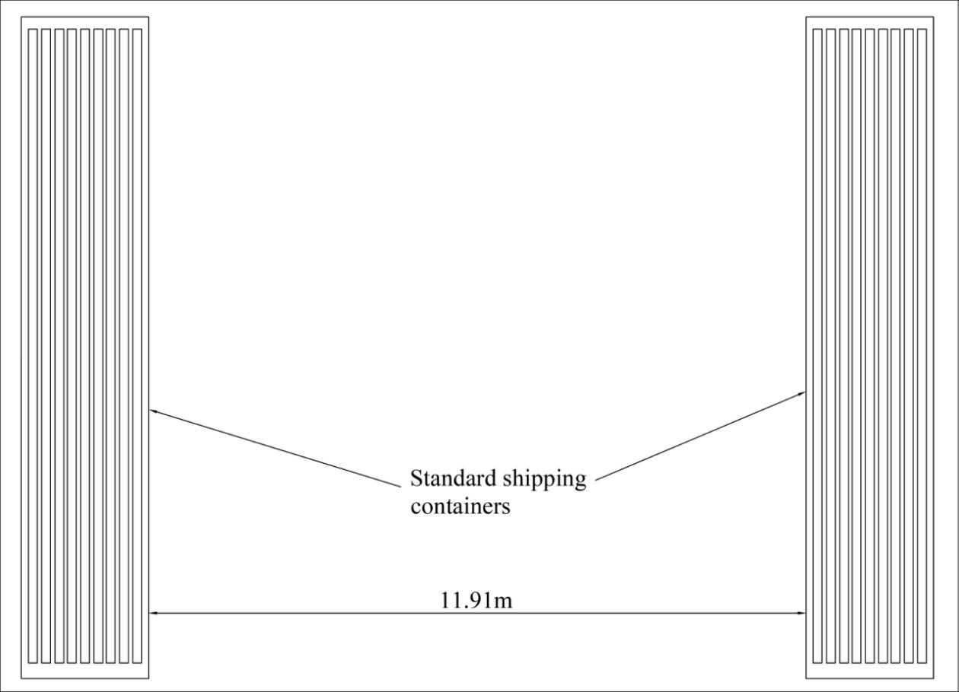

NB: Containers should be fixed down or weighted with a minimum of 500kg/m in each container. Don't continue with assembly until this is completed.

STEP 2 - BASE PLATE LAYOUT AND FIXING
1. Position carefully the base plates (Part #6L & #6R) on each side to container tops -
a. Outside of outer portal to outside of outer portal measurement is 12.72m.
b. The measurement between the centre of each adjoining spigot is 2.017m (refer to exploded diagram).
c. The ratchet strap ring located on each base plate, should be positioned close to the outer portal, not the inside - please check this correct before welding.
2. Weld the base plates to container tops securely. Note: welds can go through the 4 holes on each plate as well as around perimeter of each plate.
3. Weld securely the 4 Choke Wire Tensioning Brackets (Part #20) to the inside edges of the containers, approx 400mm directly below each of the corner base plates.
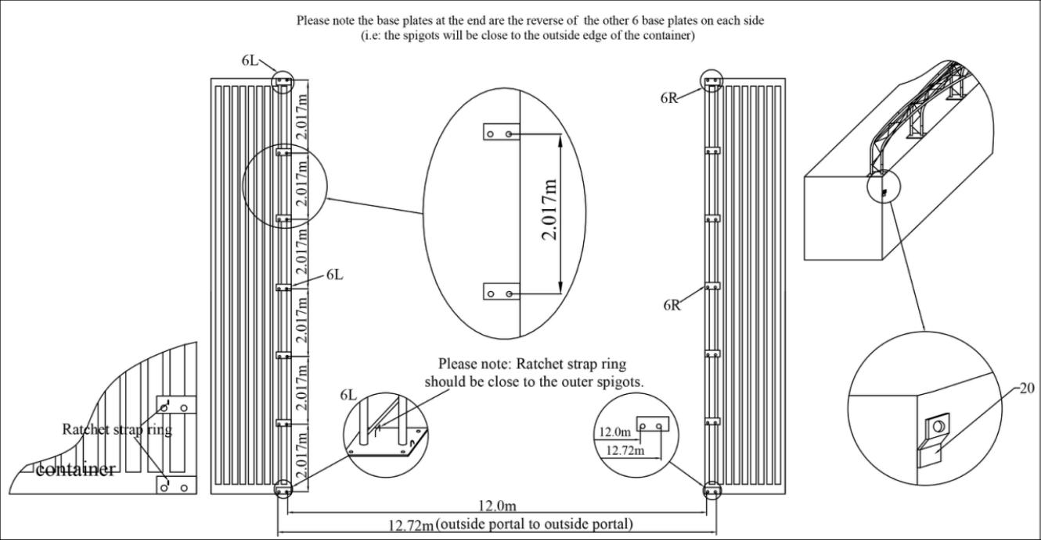

NOTE: When installing, weld the base plates to the tops of the containers securely first. Do not attempt to assemble the rest of the frame into unsecured base plates.
STEP 3 - FRAME ASSEMBLY
- Assemble ALL portals on the ground first.
2. Each portal is made up of 1 x Part #1(Center roof section), 2 x Part #2 (Mid roof tubing), 2 x Part #3 (Lower roof tubing) and 2 x Part #4 (Shoulder tubing). Bolt together using Bolts - Part #9.
3. 14 bracing brackets, Part #8 are required for the first 2 portals and the last 2 portals. These bracing brackets are fixed to the upper portal frame.
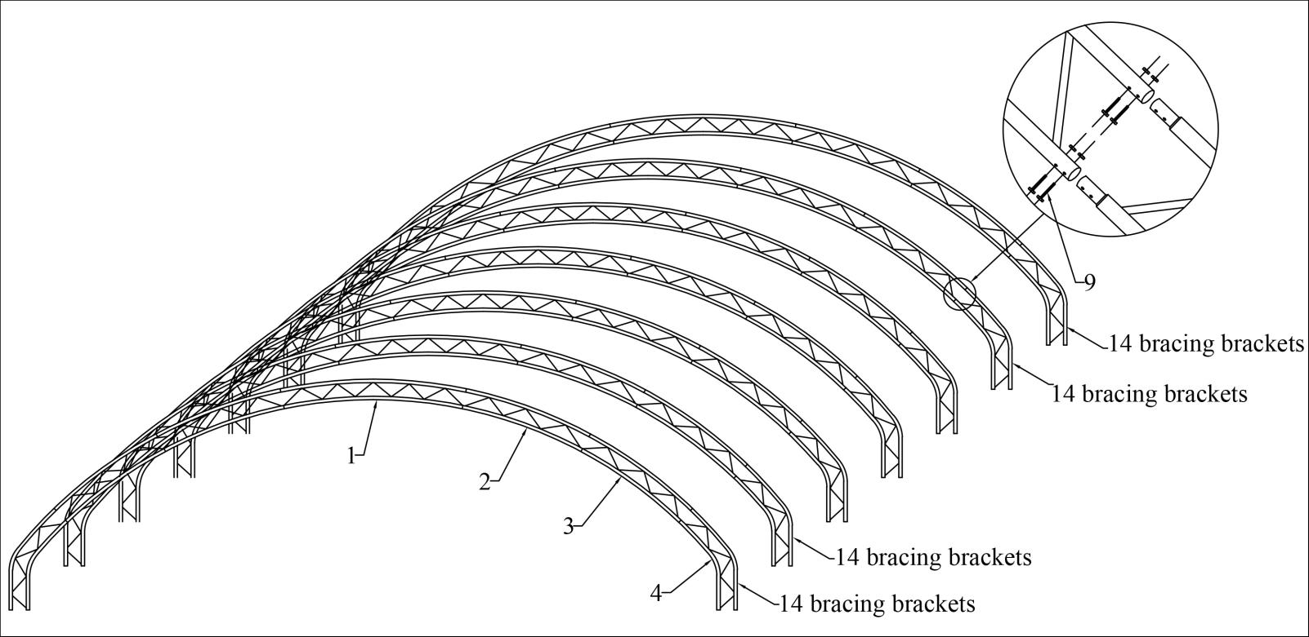

STEP 4 - FRAME ASSEMBLY CONTINUED
- Lift the 1st fully assembled portal (with 14 bracing brackets) onto the corner base plates.

- Drop the portal legs onto the spigots of the base plate and secure using bolt Part #9.

- Repeat this process with the second portal (portal which includes 14 bracing brackets).

- Connect the first two portals with the Purlins (Part #5) on both upper and lower chords
of the portals by Bolts (Part #10).

- Connect bracing tube (Part #7/7A) to portals using brackets and Bolts (Part #11).
Bracing is required only between the first two portals, and the last two portals.

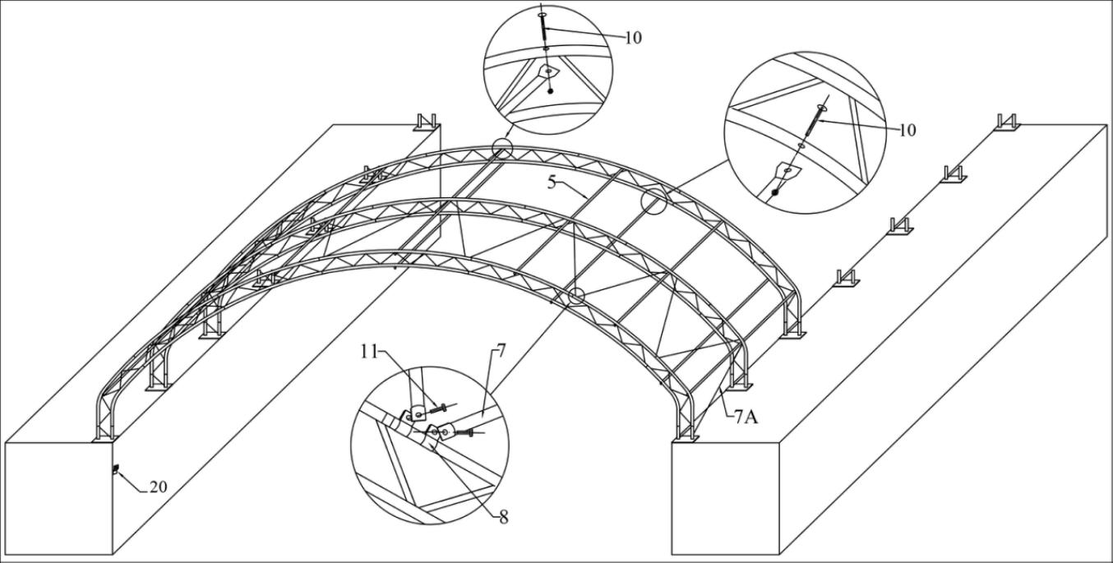

NOTE: Do not attempt to assemble the entire frame including the horizontal connections on the ground and lift into place.

STEP 5 - FRAME ASSEMBLY CONTINUED
1. Repeat the Step 4 (1 - 4), until all portals are positioned and bolted to base plates, and all purlins are connected using Bolts (Part #10).
- Connect Bracing between the last two portals, using the bracing brackets (Part #8) and Bolts (Part #11).
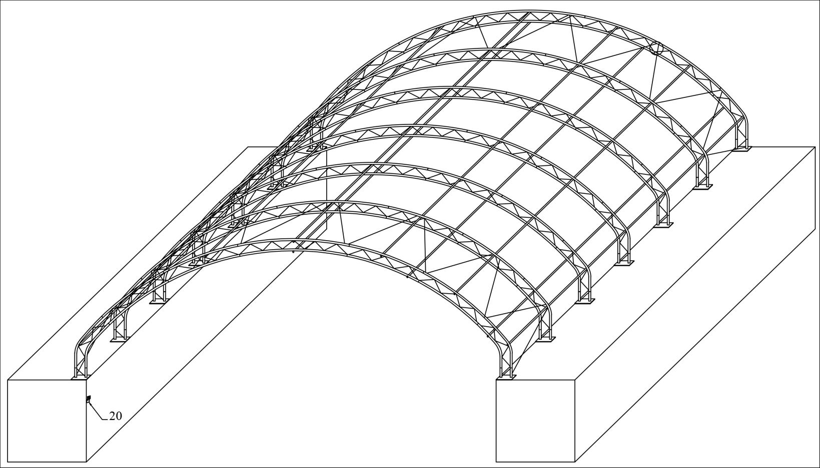
STEP 6 - COVER INSTALLATION
PLEASE NOTE: ONLY ATTEMPT COVER INSTALLATION IN LITTLE OR NO WIND

- Unfold the cover carefully to locate the two end edges of the cover. The ends of the cover have a line of eyelets on the underside, close to the end pouch of the cover. A leader rope is pre installed in the end pouch of the cover. Do not remove the leader rope until you are ready to install the choke wires.

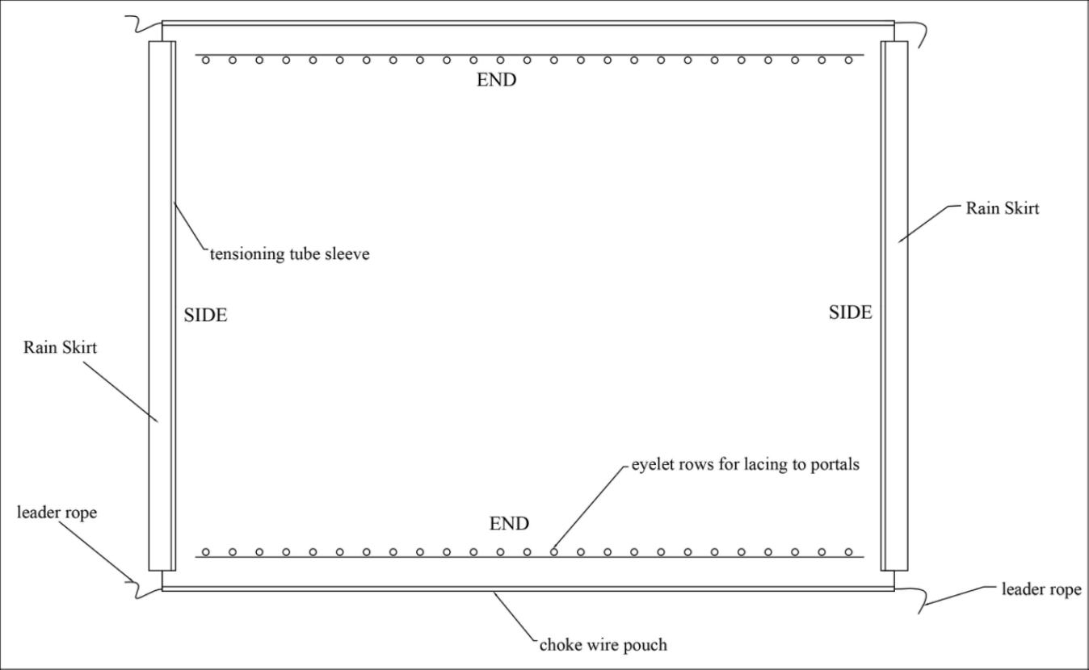

- Insert one set of the tensioning tubes (Part #15), into the tensioning tube sleeve that will be lead side of the cover, when being pulled over the frame.

- Tie ropes to the two ends of the tensioning tube, and another two mid points of the tensioning tube. Throw the ropes across the top of the shelter frame to the opposite side. Ropes should be long enough.

- Position one man per rope on the ground on the opposite side of the container.

- Collectively ease the cover over the top of the frame, from one side to the other, checking from the underside that the cover is not catching on any parts of the frame, portals or purlins. Work steadily and evenly, without excessive force. Use man power only, don't attempt to pull the cover over with any type of machinery.

- Once cover is positioned on the frame, secure in place by tying the leader ropes to the four corners of the containers temporarily.

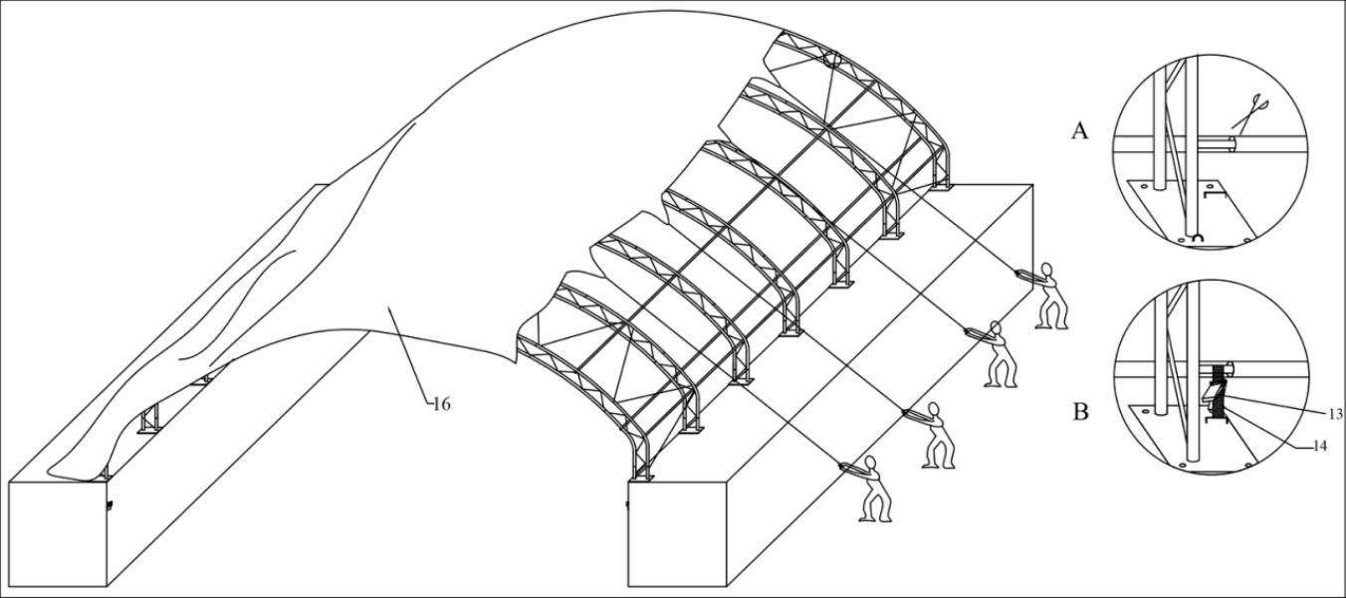

NOTE: Ensure the cover is the right way around and have an even amount of cover overhanging at both ends of the frame. Tensioning tube sleeves are on the underside and are on the sides of the cover only.

- When ready to install the choke wires (Part #21), untie one side only of the leader rope at each end of the cover. Tape an end of the tensioning wire to the end of the leader rope by overlapping/overlaying them approximately 20 – 30cm. Wrap tape around the entire overlap, but ensure it stays flat so that it can still fit through the pouch. Gently ease the tensioning wire through the pouch by pulling the leader rope carefully from the opposite side, until the tensioning wire is all the way through, and the leader rope is out completely. Spraying the taped area with a small amount of silicone spray will help the overlapped wire slide through the pouch easily. Repeat this process for other end of the cover. Do not use the leader ropes for long term securing of the cover.

See Photo of taping process:
- Gently pull the tensioning wire through the pouch by pulling the leader rope carefully from the opposite side. Insert second set of tensioning tubes into other sleeve of the cover. Ensure you push the tubes to the very end of the sleeves, then feed back and centre the tubes in the sleeves. Install plastic end caps (Part #18) to the ends of the tensioning tube on both sides.

- Square the cover up on frame, ensure it is evenly placed, with equal overhang at both end portals.

- Fix the choke wires securely at each end to a turnbuckle (Part #22) by threading wire through the eye of the buckle and securing using a “U” bolt (Part #22). Fix turnbuckle hook to the choke wire brackets (Part #20) that were previously welded to the container sides under each of the four inside corners. Tension the ends of the cover by tightening the turnbuckles and ensure the cover ends are tight.

11. Lace the underside of the main cover to end portals of the shelter using the eyelets on the cover and the lacing rope (Part #17). Start lacing from the centre top and work evenly down each side to the base plates. Only secure the ends of the lacing rope to the frame. Do not tie off to the cover.

12. Cut small incisions into the tensioning tube sleeves directly above each ratchet on each base plate. The incision should be wide enough for the ratchet strap to slide through.
CAUTION–DO NOT CUT THROUGH THE MAIN COVER, ONLY THE SLEEVE CONTAINING THE TENSIONING TUBE.

- Thread the ratchet webbing strap (Part #14) over the tensioning tube at each ratchet location and feed the end through the steel loop (Ratchet strap ring) on the base plate. Thread the ends of the strap into the tie down ratchet (Part #13). Tension only loosely at this stage until all ratchets have been loaded.

- Once all ratchets are loaded, progressively tension each ratchet properly starting at the centre ratchet and working evenly out to the ends on each container. This will ensure even tension is spread over the cover and that there are no wrinkles in the cover.

- Check again the lacing rope, retension if necessary, and check that the choke wires are all tight and that all knots are tied securely.

- After a day or two the cover may settle on the frame further, and you will be required to recheck the tensioning of all the ratchets, the lacing and the choke wires. It is important to maintain good tension of the cover on the frame at all times. You should not be able to get your hand between the cover and the portals.
